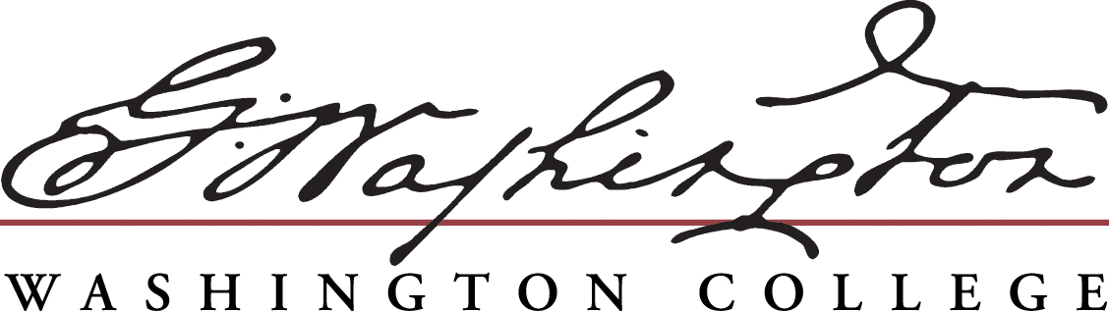 |  |  |  | GLOBAL EDUCATION OFFICE  409 Washington Avenue  Chestertown, MD 21620  PHONE 410-810-7100  FAX 410-810-7451  EMAIL geo@washcoll.edu  WEB https://www.washcoll.edu/offices/global-education  and https://washcoll-sa.terradotta.com/
Semester and Academic Year Study Options
Country |  | Institution |  | City |  | Exchange/Payment Type |  | Language*
Argentina |  | Pontificia Universidad Católica |  | Buenos Aires |  | Full Exchange |  | Spanish
Australia |  | Bond University |  | Gold Coast |  | Tuition Exchange |  | English
Brazil |  | Pontificia Universidade Católica |  | Rio de Janeiro |  | Tuition Exchange |  | English/Portuguese
China |  | China Studies Institute |  | Beijing |  | Tuition/Room Exchange |  | English
China |  | Lingnan University |  | Hong Kong |  | Tuition/Room Exchange |  | English
Ecuador |  | Universidad San Francisco |  | Quito |  | Tuition Exchange |  | Spanish
Egypt |  | American University in Cairo |  | Cairo |  | Tuition Exchange |  | English
England |  | Hansard Scholar Programme |  | London |  | Tuition/Room Exchange |  | English
England |  | Royal Holloway University of London |  | Egham |  | Tuition Exchange |  | English
England |  | University of Hull |  | Hull |  | Tuition Exchange |  | English
Finland |  | University of Oulu |  | Oulu |  | Full Exchange |  | English
France |  | American Business School |  | Paris |  | Tuition/Room Exchange |  | English
France |  | Universite d’Artois |  | Arras |  | Tuition Exchange |  | French
France |  | Université Grenoble Alpes |  | Grenoble |  | Tuition Exchange |  | French
Germany |  | Eberhard-Karls-University |  | Tubingen |  | Tuition Exchange |  | German
Germany |  | Johannes Gutenberg-University |  | Mainz |  | Tuition Exchange |  | German
Ireland |  | University College Cork |  | Cork |  | Tuition Exchange |  | English
Israel |  | Ben-Gurion University of Negev |  | Beer Sheva |  | Tuition Exchange |  | English
Israel |  | The Arava Institute (Ben-Gurion U.) |  | Kibbutz Ketura |  | Tuition Exchange |  | English
Italy |  | Universita Cattolica del Sacro Cuore |  | Milan |  | Tuition Exchange |  | English
Japan |  | Meiji Gakuin University |  | Yokohama |  | Tuition Exchange |  | English
Morocco |  | Al Akhawayn University |  | Ifrane |  | Full Exchange |  | English
Netherlands |  | Leiden University |  | Leiden & Hague |  | Tuition Exchange |  | English
Peru |  | Pontificia Universidad Católica |  | Lima |  | Tuition Exchange |  | Spanish
Senegal |  | University of Minnesota (MSID) |  | Dakar |  | Tuition Exchange |  | French
Scotland |  | University of St. Andrews, Scotland |  | St. Andrews |  | Tuition Exchange |  | English
South Africa |  | Rhodes University |  | Grahamstown |  | Full Exchange |  | English
South Korea |  | Yonsei University |  | Seoul |  | Tuition/Room Exchange |  | English
Spain |  | Universidad de Nebrija |  | Madrid |  | Tuition Exchange |  | Spanish
Turkey |  | Bogazici University |  | Istanbul |  | Tuition Exchange |  | English
*French, Spanish and German programs require a 300-level proficiency.
All financial aid and scholarships travel with students when they study abroad
Tuition Exchange: What is Paid To Washington College: Tuition & Off-campus Study Fee (currently $890); students on tuition exchange do not pay the Student Service Fee (currently $748). What is Paid To Host Institution: Room and Board.
Tuition/Room Exchange: What is Paid To Washington College: Tuition, Room, & Off-campus Study Fee (currently $890); students on tuition/room exchange do not pay the Student Service Fee (currently $748). What is Paid To Host Institution: Board
Full Exchange: What is Paid To Washington College: Tuition, Room, Board, & Off-campus Study Fee (currently $890)

Students can take Major, Minor, Distribution, or Elective credits at their host institution, and all credits taken abroad will appear as Washington College courses on student transcripts.
Students can study abroad for a semester or a year as early as their Sophomore Spring semester and as late as their Senior Fall semester, though certain majors limit study abroad to specific semesters.
GLOBAL EDUCATION OFFICE
409 Washington Avenue  Chestertown, MD 21620
PHONE 410-810-7100  FAX 410-810-7451
EMAIL geo@washcoll.edu
WEB https://www.washcoll.edu/offices/global-education and
https://washcoll-sa.terradotta.com/

 | Short-Term, Faculty Led Abroad Programs
 | Country |  | Faculty Leader |  | Area of Study |  | Term
 | Bermuda |  | Dr. Van Meter |  | Environmental Science |  | Summer Session
 | Europe |  | Dr. Harvey |  | Global Business |  | Summer Session
 | Cuba |  | Dr. Schweitzer & Dr. Lampman |  | Music & Anthropology |  | Winter Session
 | Ecuador |  | Dr. Sherman |  | Environmental Studies |  | Summer Session
 | Denmark |  | Dr. Schindler |  | Experimental Archaeology |  | Summer Session
 | England/Ireland (Kiplin Hall) |  | Dr. Gillin |  | English & Literature |  | Summer Session
 | England (Oxford Seminar) |  | Dr. Prud’homme |  | Politics, Religion, & Culture |  | Summer Session
 | India |  | Dr. McCollum & Dr. Leupold |  | Music & Anthropology |  | Winter Session
 | Nicaragua |  | Dr. Carr & Dr. Van Meter |  | Biology |  | Winter Session
 | Tanzania |  | Dr. Shad & Dr. Lampman |  | International Studies |  | Summer Session

The Short-Term Faculty-Led Abroad programs are two or three week programs led by Washington College faculty during the college’s winter or summer breaks. Each program is dedicated to a specific area of study and is often counts as one course credit (4 credits) in the corresponding department. Students do not need to be majoring in that specific area to participate in these trips, however; all trips are open to all Washington College students.

Cost varies by program, and is usually a flat fee covering all transportation and accommodation fees and the College’s off-campus study fee for short-term programs (currently $445). These program fees are separate from a student’s standard tuition costs. Short-Term, Faculty-Led Abroad Program fees are eligible to be offset or covered by various Washington College scholarship and grant opportunities, such as the Cater Society for Junior Fellows. There is no limit to how many Short-Term, Faculty-Led Programs a student can participate in.

Each trip does not run every year – some run every other year. Please contact the program’s Faculty Leader(s) for details regarding program frequency.

Specific questions regarding application, trip details, or pricing should be directed to the program’s Faculty Leader(s), but the Global Education Office is available to answer any questions regarding travel abroad.

